

**Department of Computer Science and Engineering**

**LakiReddy Bali Reddy College of Engineering (Autonomous)**

**Accredited by NAAC & NBA (Under Tier - I)**

# Affiliated to JNTUK, Kakinada; ISO 9001:2015 Certified 2022-23

Web Application Development using

Full Stack - Module-I (Frontend Development)

A Skill Oriented Course Web Application / Project report

Submitted in the partial fulfillment of the requirements for

the award of the degree of

Bachelor of Technology

in

Computer Science and Engineering

Your Name : JAGGINENI GANESH

ROLL NO:21761A0590

UNDER THE GUIDENCE

OF

MR.R.ASHOK

ASSISTANT PROFESSOR,

DEPT OF CSE.

**LAKIREDDY BALIREDDY COLLAGE OF ENGINNERING**

**(Autonomous)**



This is to certify that is a bonafide record of the practical work done by Mr./Ms **JAGGINENI GANESH** Bearing Regd.Num : **21761A0590** of B.Tech **III** semester **COMPUTER SCIENCE AND ENGINEERING** branch **CSE** Section **B** in the **FULL STACK DEVLOPMENT MODULEI (FrontendDevelopment)** lab during the academic year: **2022-2023.**

No of Experiments/modules ……..

No of Experiments/modules done ……

**Date : Signature of the Faculty**

**INTERNAL EXAMINER EXTRANAL EXAMNER**



# Certificate

This is to certify that the Skill Oriented Course Web Application / Project entitled “**Web Application Development using Full Stack - Module-I (Frontend Development)**” is being submitted by **JAGGINENI GANESH** in partial fulfillment for the award of B. Tech in Computer Science & Engineering to the Jawaharlal Nehru Technological University Kakinada is a record of bonafide work carried out by him/her under our guidance.

The results embodied in this Skill Oriented Course Web Application / Project report have not been submitted to any other University or Institute for the award of any degree or diploma.

**Project guide Head of the department**

Mr.R.Ashok Dr. D. Veeraiah

Assistant Professor

## **ACKNOWLEDGEMENT**

I would like to thank **Mr. R.Ashok** Assistant Professor**,** CSE department for the encouraging and support in carrying out this Skill Oriented Course Web Application / Project.

I also take the privilege to record my thanks to **Dr. D.Veeraiah,** Professor,Head of the Department of CSE whose encouragement, cooperation and valuable support crown my success.

I express my thanks to the support given by management in completing my Web Application / Project. I also express my sincere gratitude & deep sense of respect to the Principal, **Dr.K.Appa Rao** for making us available all the required assistance and his support and inspiration to carry out this Skill Oriented Course Web Application / Project in the Institute.

I am thankful to the teaching and non-teaching staff of CSE department for their direct as well as indirect help in my Skill Oriented Course Web Application / Project.

I am elated to avail my selves to this opportunity to express my deep sense of gratitude to my parents.

**Web Application Development using**

**Full Stack - Module-I (Frontend Development)**

**Abstract**

This webpage is mainly about a hospital management website.This webpage mainly consists of loading, home,s service, about, professionaldoctorsdetails,patientreviewandpricing.HTML,CSS,JAVASCRIPT are used to make this webpage and Javascript is used for the login page and styling is applied for all the html pages.Social media links for the hospital were being added for the webpage and locations also been added to the page.Users can use this webpage comfortblly and webpage can be used for the external purposes.All hospital details were updated in the webpage.Membership feature had been added to the webpage and the viewers can add their membership to the gym.

**CONTENTS**

|  |  |  |
| --- | --- | --- |
| **S.NO** | **CONCEPTS** | **PAGE NO** |
| 1. | Introduction | **7** |
| **2.** | Working | **8** |
| **2.1.** | Hyper Text Markup Language (HTML) | **8-15** |
| **2.2.** | Cascading Style Sheets (CSS) | **15-22** |
| **2.3.** | Java Script (JS) | **22-26** |
| **2.4** | XML | **26-28** |
| **2.5** | JSON | **28-29** |
| **2.6** | JQUERY | **30-32** |
| **4.** | Implementation | **32-33** |
| **4.1** | Code | **34-59** |
| **4.2** | Pictures | **60-65** |
| **5.** | Result | **65-66** |
| **6.** | References | **66-67** |

## **Front-end Development**

In a nutshell, front-end web development, also called client-side development, refers to writing Hyper Text Markup Language (HTML), Cascading Style Sheets (CSS) and JavaScript code for a website or web application so that users can see and interact directly with them.

The following are the main front-end development goals:

* Accessibility: This is where they ensure that everyone - irrespective of their mobile device (think smartphones and tablets) - can easily access the said website or app. Basically, here front-end developers get their site to show up correctly in browsers on all devices. This is done with the help of a responsive web design using stylesheets in CSS.
* Performance: Performance here is measured in terms of the render time. So frontend developers work on the code to make sure that the site / app opens up quickly.
* Speedy Development: This is about a quick and smooth development process that is also high on efficiency.

A front-end developer develops websites and applications using HTML, CSS,

JavaScript and DOM. DOM or the Document Object Model is a programming API

(Application Programming Interface) for HTML and Extensible Markup Language (XML) documents. So, DOM defines the logical structure of documents and the way a document is accessed and manipulated.

**The following are some of the roles and responsibilities of Front- End Developers:**

* Design and implement the functional techniques and principles of web design
* Create codes that are reusable in the future
* Define the right balance between functional and aesthetic design.
* Enhance the speed and scalability of the website.

## **Hyper Text Markup Language (HTML)**

**HTML** stands for Hyper Text Markup Language. It is used to design web pages using a markup language. HTML is the combination of Hypertext and Markup language. Hypertext defines the link between web pages. A markup language is used to define the text document within the tag which defines the structure of web pages. This language is used to annotate (make notes for the computer) text so that a machine can understand it and manipulate text accordingly. Most markup languages (ex: HTML) are human-readable. The language uses tags to define what manipulation has to be done on the text.

HTML is a markup language used by the browser to manipulate text, images, and other content, in order to display it in the required format. HTML was created by Tim Berners-Lee in 1991. The first-ever version of HTML was HTML 1.0, but the first standard version was HTML

2.0, published in 1995.

**Features of HTML:**

* It is easy to learn and easy to use.
* It is platform-independent.
* Images, videos, and audio can be added to a web page.
* Hypertext can be added to the text.
* It is a markup language.

**Advantages:**

* HTML is used to build websites.
* It is supported by all browsers.
* It can be integrated with other languages like CSS, JavaScript, etc.

Example:

<!DOCTYPE html>  
<html>  
<head>  
<title>Page Title</title>  
</head>  
<body>  
  
<h1>My First Heading</h1>  
<p>My first paragraph.</p>  
  
</body>  
</html>

### **Example Explained**

* The <!DOCTYPE html> declaration defines that this document is an HTML5 document
* The <html> element is the root element of an HTML page
* The <head> element contains meta information about the HTML page
* The <title> element specifies a title for the HTML page (which is shown in the browser's title bar or in the page's tab)
* The <body> element defines the document's body, and is a container for all the visible contents, such as headings, paragraphs, images, hyperlinks, tables, lists, etc.
* The <h1> element defines a large heading
* The <p> element defines a paragraph

## **What is an HTML Element?**

An HTML element is defined by a start tag, some content, and an end tag:

<tagname> Content goes here... </tagname>

The HTML **element** is everything from the start tag to the end tag:

<h1>My First Heading</h1>

<p>My first paragraph</p>

|  |  |  |
| --- | --- | --- |
| Start Tag | Element content | End Tag |
| <h1> | My First Heading | </h1> |
| <p> | My First paragraph | </p> |
| <br> | None | None |

**Web Browsers**

The purpose of a web browser (Chrome, Edge, Firefox, Safari) is to read HTML documents and display them correctly.

A browser does not display the HTML tags, but uses them to determine how to display the document:

## **HTML Page Structure**

Below is a visualization of an HTML page structure:

<html>

<head>

<title>Page title</title>

</head>

<body>

<h1>This is a heading</h1>

<p>This is a paragraph.</p>

<p>This is another paragraph.</p>

</body>

</html>

**HTML Tables**:

The HTML tables allow web authors to arrange data like text, images, links, other tables, etc. into rows and

columns of cells.

The HTML tables are created using the<table> tag in which the <tr>tag is used to create table rows

and <td> tag is used to create data cells.

**Table Heading:**

Table heading can be defined using <th> tag. This tag will be put to replace <td> tag, which is used to represent actual data cell. Normally you will put your top row as table heading as shown below, otherwise you can use <th>

element in any row.

**Cell padding and Cell spacing Attributes:**

There are two attributes called cell padding and cell spacing which you will use to adjust the white space in your table cells. The cell spacing attribute defines the width of the border, while cell padding represents the distance between cell borders and the content within a cell.

**Colspan and Rowspan Attributes:**

You will use Colspan attribute if you want to merge two or more columns into a single column. Similar way you will use rowspan if you want to merge two

or more rows.

**Table Header, Body, and Footer:**

Tables can be divided into three portions : a header, a body, and a foot. The head and foot are rather similar to headers and footers in a word-processed document that remain the same for every page, while the body is the main content holder of the table.

The three elements for separating the head, body, and foot of a table are: • <thead> - to create a separate table header.

• <tbody> - to indicate the main body of the table.

> <tfoot>- to create a separate table footer.

A table may contain several <tbody> elements to indicate different pages or groups of data.

But it is notable that <thead> and <tfoot> tags should appear before <tbody>

**HTML Forms:**

HTML Forms are required when you want to collect

some data from the site visitor. For example during user registration you would like to collect information such as name, email address, credit card, etc.

A form will take input from the site visitor and then will post it to a back-end application such as CGI, ASP Script, or PHP script etc. The back-end application will perform required processing on the passed data based on defined business logic inside the application. There are various form elements available like text fields, text area fields, drop-down menus,

radio buttons, check boxes, etc.

**Password input controls:-**

This is also a single-line text input, but it masks the character as soon as a user enters it. They are also created by using HTML <input> tag but type attribute is set to password.

**Multiple-Line Text Input Controls:-**

This is used when the user is required to give details that may be longer than a single sentence. Multi-line input controls are created using HTML <text area> tag.

Checkbox Control

Check boxes are used when more than one option is required to be selected. They are also created using HTML <input> tag but type attribute is set to checkbox..

**Radio Button Control:-**

Radio buttons are used when out of many options, just one option is required to be selected. They are also created using HTML <input> tag but type attribute is set to radio.

**Select Box Control:-**

A select box, also called drop down box which provides option to list down various options in the form of drop down list, from where a user can select one or more options.

**Button Controls:-**

There are various ways in HTML to create clickable buttons. You can also create a clickable button using <input> tag by setting its type attribute to button ( submit, reset, button, image ).

**HTML Frames:-**

HTML frames are used to divide your browser window into multiple sections where each section can load a separate HTML document. A collection of frames in the browser window is known as a frame set. The window is divide into frames in a similar way the tables are organized: into rows and columns

To use frames on a page we use <frameset> tag instead of <body> tag. The <frameset> tag defines how to divide the window into frames. The rows attribute of <frameset> tag defines horizontal frames and cols attribute defines vertical frames. Each frame is indicated by <frame> tag and it defines which HTML document shall open into the frame.

**The <frameset> Tag Attributes:**

Following are important attributes of the <frameset> tag:

**Cols:**

specifies how many columns are contained in the frameset and the size of each column. You can specify the width of each column in one of four ways: • Absolute values in pixels. For example to create three vertical frames, use cols="100, 500,100".

• A percentage of the browser window. For example to create three vertical frames, use cols="10%, 80%, 10%".

• Using a wildcard symbol. For example to create three vertical frames, use cols="10%,,10%". In this case wildcard takes

remainder of the window.

• As relative widths of the browser window. For example to create three vertical frames, use cols="3*,2,1*". This is an alternative to percentages. You can use relative widths of the browser window. Here the window is

divided into sixths: the first column takes up half of the window, the second takes one third, and the third takes one sixth.

**Rows:**

This attribute works just like the cols attribute and takes the same values, but it is used to specify the rows in the frameset. For example to create two horizontal frames, use rows="10%, 90% ". You can specify the height of each row in the same way as explained above for columns.

**Border:**

This attribute specifies the width of the border of each frame in pixels. For example border="S". A value of zero means no border.

**Frame border:**

This attribute specifies whether a three-dimensional border should be displayed between frames. This attribute takes value either 1 (yes) or 0 (no). For example frame border="0" specifies no border.

**Frame spacing:**

This attribute specifies the amount of space between frames in a frameset. This can take any integer value. For example frame spacing="10" means there should be 10 pixels spacing between each frames.

## **Cascading Style Sheets (CSS)**

**C**ascading **S**tyle **S**heets, fondly referred to as **CSS**, is a simply designed language intended to simplify the process of making web pages presentable. CSS allows you to apply styles to web pages. More importantly, CSS enables you to do this independent of the HTML that makes up each web page. It describes how a webpage should look: it prescribes colors, fonts, spacing, and much more. In short, you can make your website look however you want. CSS lets developers and designers define how it behaves, including how elements are positioned in the browser.

While html uses tags, CSS uses rulesets. CSS is easy to learn and understand, but it provides powerful control over the presentation of an HTML document.

Advantages of CSS:

* **CSS saves time:** You can write CSS once and reuse the same sheet in multiple HTML pages.
* **Easy Maintenance:** To make a global change simply change the style, and all elements in all the webpages will be updated automatically.
* **Search Engines:** CSS is considered a clean coding technique, which means search engines won’t have to struggle to “read” its content.
* **Superior styles to HTML:** CSS have a much wider array of attributes than HTML, so you can give a far better look to your HTML page in comparison to HTML attributes.
* **Offline Browsing:** CSS can store web applications locally with the help of an offline cache. Using this we can view offline websites.

## **Why Use CSS?**

CSS is used to define styles for your web pages, including the design, layout and variations in display for different devices and screen sizes.

<!DOCTYPE html>

<html>

<head>

<style>

body {

background-color: lightblue;

}

h1 {

color: white;

text-align: center;

}

p {

font-family: verdana;

font-size: 20px;

}

</style>

</head>

<body>

<h1>My First CSS Example</h1>

<p>This is a paragraph.</p>

</body>

</html>

## **CSS Solved a Big Problem**

HTML was NEVER intended to contain tags for formatting a web page!

HTML was created to describe the content of a web page, like:

<h1>This is a heading</h1>

<p>This is a paragraph.</p>

When tags like <font>, and color attributes were added to the HTML 3.2 specification, it started a nightmare for web developers. Development of large websites, where fonts and color information were added to every single page, became a long and expensive process.

To solve this problem, the World Wide Web Consortium (W3C) created CSS.

CSS removed the style formatting from the HTML page!

## **CSS Syntax**

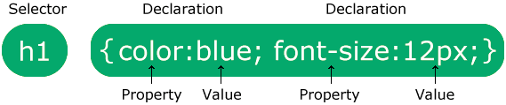

The selector points to the HTML element you want to style.

The declaration block contains one or more declarations separated by semicolons.

Each declaration includes a CSS property name and a value, separated by a colon.

Multiple CSS declarations are separated with semicolons, and declaration blocks are surrounded by curly braces.

CSS Saves a Lot of Work!

The style definitions are normally saved in external .css files.

With an external stylesheet file, you can change the look of an entire website by changing just one file!

: CSS Selectors

CSS selectors are used to "find" (or select) HTML elements based on their element name, id and class.

**The element Selector:**

The element selector selects elements based on the element name. You can select all <p> elements on a page like this (in this case, all <p> elements will be center-aligned, with a red text color):

**The id Selector:**

• The id selector uses the id attribute of an HTML element to select a specific element.

The id of an element should be unique within a page, so the id selector is used to select one unique element!

• To select an element with a specific id, write a hash (#) character, followed

by the id of the element.

**The class Selector:**

• The class selector selects elements with a specific class attribute.

• To select elements with a specific class, write a period (.) character, followed by the name of the class.

Three Ways to Insert CSS (Types of CSS):

There are three ways of inserting a style sheet:

• External style sheet

• Internal style sheet

Inline style Inline Styles

**Inline Styles:**

* An inline style may be used to apply a unique style for a single element.
* To use inline styles, add the style attribute to the relevant element. The style attribute can contain any CSS property.

**Internal Style Sheet:**

* An internal style sheet may be used if one single page has a unique style.
* Internal styles are defined within the <style> element, inside the <head> section of an HTML page:

.

**External Style Sheet:**

• With an external style sheet, you can change the look of an entire website by changing just one file!

• Each page must include a reference to the external style sheet file inside the

<link> element. The <link> element goes inside the <head> section:

**Cascading Order:**

What style will be used when there is more than one style specified for an HTML element?

Generally speaking we can say that all the styles will "cascade" into a new

"virtual" style sheet by the following rules, where number one has the highest priority:

1. Inline style (inside an HTML element)

2. External and internal style sheets (in the head section)

3. Browser default

So, an inline style (inside a specific HTML element) has the highest priority, which means that it will override a style defined inside the <head> tag, or in

an external style sheet, or a browser default value.

CSS Properties:

Text Properties:

• color: blue;

⚫ text-align: center/left/right/justify;

⚫ text-decoration: over line/line-through/underline;

⚫ text-transform: uppercase/lowercase/capitalize;

⚫ text-indent: 10px/-10px;

⚫ letter-spacing: 5px/-5px;

* line-height: 0.8;
* direction: rtl;
* word-spacing: 10px;
* text-shadow: 3px 2px red;

**Font Properties:**

1. font-family: arial;

2. font-style: normal/italic/oblique;

3. font-size: 30px;

4. font-weight: normal/bold;

5. font-variant: normal/small-caps;

**Border Properties:**

1.border style:

dotted/dashed/solid/double/groove/ridge/inset/outset/none/hidden.

2. border-width: 5px; border-width: 2px 10px 4px 20px.

3. border-color: red; Border-color: red, green blue yellow;

Note: four values indicate - first for top border, second for right border,

third for bottom border, fourth for left border.

**Background Properties:**

* background-color: red.
* background-image: URL ("image path");
* background-repeat: repeat-x/repeat-y/round/no-repeat.

⚫ background-attachment: fixed/scroll/local.

background-size: 20px 30px.

⚫ background-position: right top/right bottom/left top/left bottom.

or 30px,20px.

**Margin Properties:**

⚫ margin-top: 100px.

* margin-bottom: 100px.
* margin-right: 150px.
* margin-left:80px.

**Link Properties:**

* a: link- uninvited link
* a: hover-when mouse is on it
* a: active- when mouse click on it
* a: visited-after mouse clicked

**Layouts:**

**HTML Layout Elements**

Websites often display content in multiple columns (like a magazine or newspaper).

HTML5 offers new semantic elements that define the various parts of a web page:

* <header>- Defines a header for a document or a section
* <nav>- Defines a container for navigation links
* <section>- Defines a section in a document
* <article> Defines an independent self-contained article

## **Java Script (JS)**

**JavaScript (JS)** is the world’s most popular lightweight, interpreted compiled programming language. It is also known as a scripting language for web pages. It can be used for [Client-side](https://www.geeksforgeeks.org/server-side-client-side-programming/) as well as [Server-side](https://www.geeksforgeeks.org/server-side-client-side-programming/) developments.

JavaScript is the most popular programming language for both client-side and server-side to make interactive web pages. It is mainly used to develop websites and web-based applications.

* **Creating Interactive Websites:** JavaScript is used to make the web pages dynamic and interactive. It means using JavaScript, we can change the web page content and styles dynamically.
* **Building Applications:** JavaScript is used to make web and mobile applications. To build the web and mobile apps, we can use most popular JavaScript frameworks like – ReactJS, React Native, Node.js etc.
* **Web Servers:** We can make robust server applications using JavaScript. To be precise we use JavaScript frameworks like Node.js and Express.js to build these servers.
* **Game Development:** JavaScript can be used to design Browser games. In JavaScript, lots of game engines available that provide frameworks for building games.

* JavaScript is an advanced programming language that makes web pages more interactive and dynamic whereas HTML is a standard markup language that provides the primary structure of a website.
* JavaScript simply adds dynamic content to websites to make them look good and HTML work on the look of the website without the interactive effects and all.
* JavaScript manipulates the content to create dynamic web pages whereas HTML pages are static which means the content cannot be changed.
* JavaScript is not cross-browser compatible whereas HTML is cross-browser compatible.
* JavaScript can be embedded inside HTML but HTML cannot be embedded inside

### Single-line input in the Web Console

The [Web Console](https://firefox-source-docs.mozilla.org/devtools-user/web_console/index.html) shows you information about the currently loaded Web page, and also includes a JavaScript interpreter that you can use to execute JavaScript expressions in the current page.

To open the Web Console (Ctrl+Shift+I on Windows and Linux or Cmd-Option-K on Mac), open the **Tools** menu in Firefox, and select "**Developer ▶ Web Console**".

The Web Console appears at the bottom of the browser window. Along the bottom of the console is an input line that you can use to enter JavaScript, and the output appears in the panel above:

### Multi-line input in the Web Console:

The single-line input mode of the Web Console is great for quick testing of JavaScript expressions, but although you can execute multiple lines, it's not very convenient for that. For more complex JavaScript, you can use the [multi-line input mode](https://firefox-source-docs.mozilla.org/devtools-user/web_console/the_command_line_interpreter/index.html#multi-line-mode).

### Hello world Program

To get started with writing JavaScript, open the Web Console in multi-line mode, and write your first "Hello world" JavaScript code:

(function(){

"use strict";

/* Start of your code */

function greetMe(yourName) {

alert(`Hello ${yourName}`);

}

greetMe('World');

/* End of your code */

})();

Copy to ClipboardCopy to Clipboard

Press Cmd+Enter or Ctrl+Enter (or click the **Run** button) to watch it unfold in your browser!

In the following pages, this guide introduces you to the JavaScript syntax and language features, so that you will be able to write more complex applications.

But for now, remember to always include the (function(){"use strict"; before your code, and add })(); to the end of your code. The [strict mode](https://developer.mozilla.org/en-US/docs/Web/JavaScript/Reference/Strict_mode) and [IIFE](https://developer.mozilla.org/en-US/docs/Glossary/IIFE) articles explain what those do, but for now they can be thought of as doing the following:

1. Prevent semantics in JavaScript that trip up beginners.
2. Prevent code snippets executed in the console from interacting with one another (e.g., having something created in one console execution being used for a different console execution).

**Client-side JavaScript**

Client-side JavaScript is the most common form of the language. The script should be included in or referenced by an HTML document for the code to be interpreted by the browser. It means that a web page need not be a static HTML, but can include programs that interact with the user, control the browser, and dynamically create HTML content. The JavaScript client-side mechanism provides many advantages over traditional CGI server-side scripts. For example, you might use JavaScript to check if the user has entered a valid e-mail address in a form field. The JavaScript code is executed when the user submits the form, and only if all the entries are valid, they would be submitted to the Web Server. JavaScript can be used to trap user-initiated events such as button clicks, link navigation, and other actions that the user initiates explicitly or implicitly.

**JavaScript – Objects**

JavaScript is an Object Oriented Programming (OOP) language. A programming language can be called object-oriented if it provides four basic capabilities to developers –

* **Encapsulation −** the capability to store related information, whether data or methods, together in an object.
* **Aggregation −** the capability to store one object inside another object.
* **Inheritance −** the capability of a class to rely upon another class (or number of classes) for some of its properties and methods.
* **Polymorphism −** the capability to write one function or method that works in a variety of different ways. Objects are composed of attributes. If an attribute contains a function, it is considered to be a method of the object, otherwise the attribute is considered a property.

**Object Properties**

Object properties can be any of the three primitive data types, or any of the abstract data types, such as another object. Object properties are usually variables that are used internally in the object's methods, but can also be globally visible variables that are used throughout the page. The syntax for adding a property to an object is

objectName.objectProperty = propertyValue;

**For example –**

The following code gets the document title using the "title" property of the document object.

var str = document.title;

**XML**

XML (Extensible Markup Language) is a markup language similar to [HTML](https://developer.mozilla.org/en-US/docs/Glossary/HTML), but without predefined tags to use. Instead, you define your own tags designed specifically for your needs. This is a powerful way to store data in a format that can be stored, searched, and shared. Most importantly, since the fundamental format of XML is standardized, if you share or transmit XML across systems or platforms, either locally or over the internet, the recipient can still parse the data due to the standardized XML syntax.

There are many languages based on XML, including [XHTML](https://developer.mozilla.org/en-US/docs/Glossary/XHTML), [MathML](https://developer.mozilla.org/en-US/docs/Web/MathML), [SVG](https://developer.mozilla.org/en-US/docs/Web/SVG), [RSS](https://developer.mozilla.org/en-US/docs/Glossary/RSS), and [RDF](https://developer.mozilla.org/en-US/docs/Glossary/RDF). You can also define your own.

## Structure of an XML document

The whole structure of XML and XML-based languages is built on [tag](https://developer.mozilla.org/en-US/docs/Glossary/Tag)s.

### XML declaration:

XML - declaration is not a tag. It is used for the transmission of the meta-data of a document.

<?xml version="1.0" encoding="UTF-8"?>

#### Attributes

version:

Used version XML in this document.

encoding :

Used encoding in this document.

### Comments

<!-- Comment -->

## "Correct" XML (valid and well-formed)

### Correct design rules:

For an XML document to be correct, the following conditions must be fulfilled:

* Document must be well-formed.
* Document must conform to all XML syntax rules.
* Document must conform to semantic rules, which are usually set in an XML schema or a DTD ([**Document Type Definition**](https://developer.mozilla.org/en-US/docs/Glossary/Doctype)**)**.

### Example:

<?xml version="1.0" encoding="UTF-8"?>

<message>

<warning>

Hello World

<!--missing </warning> -->

</message>

Copy to Clipboard

Now let's look at a corrected version of that same document:

<?xml version="1.0" encoding="UTF-8"?>

<message>

<warning>

Hello World

</warning>

</message>

A document that contains an undefined tag is invalid. For example, if we never defined the <warning> tag, the document above wouldn't be valid.

Most browsers offer a debugger that can identify poorly-formed XML documents.

JSON

# Working with JSON

* Previous
* [Overview: Objects](https://developer.mozilla.org/en-US/docs/Learn/JavaScript/Objects)
* [Next](https://developer.mozilla.org/en-US/docs/Learn/JavaScript/Objects/Object_building_practice)

JavaScript Object Notation (JSON) is a standard text-based format for representing structured data based on JavaScript object syntax. It is commonly used for transmitting data in web applications (e.g., sending some data from the server to the client, so it can be displayed on a web page, or vice versa). You'll come across it quite often, so in this article, we give you all you need to work with JSON using JavaScript, including parsing JSON so you can access data within it, and creating JSON.

### JSON structure:

As described above, JSON is a string whose format very much resembles JavaScript object literal format. You can include the same basic data types inside JSON as you can in a standard JavaScript object — strings, numbers, arrays, booleans, and other object literals. This allows you to construct a data hierarchy, like so:

{

"squadName": "Super hero squad",

"homeTown": "Metro City",

"formed": 2016,

"secretBase": "Super tower",

"active": true,

"members": [

{

"name": "Molecule Man",

"age": 29,

"secretIdentity": "Dan Jukes",

"powers": ["Radiation resistance", "Turning tiny", "Radiation blast"]

},

{

"name": "Madame Uppercut",

"age": 39,

"secretIdentity": "Jane Wilson",

"powers": [

"Million tonne punch",

"Damage resistance",

"Superhuman reflexes"

]

},

{

"name": "Eternal Flame",

"age": 1000000,

"secretIdentity": "Unknown",

"powers": [

"Immortality",

"Heat Immunity",

"Inferno",

"Teleportation",

"Interdimensional travel"

]

}

]

}

# jQuery

jQuery is a fast, small, cross-platform and feature-rich JavaScript library. It is designed to simplify the client-side scripting of HTML. It makes things like HTML document traversal and manipulation, animation, event handling, and AJAX very simple with an easy-to-use API that works on a lot of different type of browsers.

The main purpose of jQuery is to provide an easy way to use JavaScript on your website to make it more interactive and attractive. It is also used to add animation.

## **What is jQuery**

jQuery is a small, light-weight and fast JavaScript library. It is cross-platform and supports different types of browsers. It is also referred as ?write less do more? because it takes a lot of common tasks that requires many lines of JavaScript code to accomplish, and binds them into methods that can be called with a single line of code whenever needed. It is also very useful to simplify a lot of the complicated things from JavaScript, like AJAX calls and DOM manipulation.

* jQuery is a small, fast and lightweight JavaScript library.
* jQuery is platform-independent.
* jQuery means "write less do more".
* jQuery simplifies AJAX call and DOM manipulation.

## **jQuery Features**

Following are the important features of jQuery.

* HTML manipulation
* DOM manipulation
* DOM element selection
* CSS manipulation
* Effects and Animations
* Utilities
* AJAX
* HTML event methods
* JSON Parsing
* Extensibility through plug-ins

## **Why jQuery is required**

Sometimes, a question can arise that what is the need of jQuery or what difference it makes on bringing jQuery instead of AJAX/ JavaScript? If jQuery is the replacement of AJAX and JavaScript? For all these questions, you can state the following answers.

* It is very fast and extensible.
* It facilitates the users to write UI related function codes in minimum possible lines.
* It improves the performance of an application.
* Browser's compatible web applications can be developed.
* It uses mostly new features of new browsers.

So, you can say that out of the lot of JavaScript frameworks, jQuery is the most popular and the most extendable. Many of the biggest companies on the web use jQuery.

Some of these companies are:

* Microsoft
* Google
* IBM
* Netflix

## **What should you know before starting to learn jQuery?**

It is always advised to a fresher to learn the basics of web designing before starting to learn jQuery. He should learn HTML, CSS and JavaScript first. But, if you belong to a technical background, it is up to you.

If you are a fresher and want to study these subjects first.

**Designing of Website**

**Introduction of website**

In order to immediately connect with your target audience, you should include an introduction message on your website. This is a short explanatory text placed in the most prominent of positions on the layout of your web page that informs your visitors of the purpose of the website.

When care is used in crafting this message, it will help internet users determine if they are in the right location.

It is a highly effective element in allowing you to connect directly with your target audience by drawing in their interest and encouraging them to continue through your site. There are many techniques that may be utilized in ensuring optimal design and integration. Continue reading to learn more.

## Website Introduction Design Tips

Your introduction message should be compelling. It should drive a visitor to take immediate action in the ways that you desire. It must compliment your overall purpose and intent for creating the website. The following outlines several design tips that will allow your introduction to fulfill its purpose and lend to your website’s overall success:

1. **Focus on Being Concise** – The home page of your website should accomplish several goals. First, it should place an emphasis on what visitor’s should be looking for when on the site. Next, it should clearly outline where they should start and how they may proceed. Finally, it should lend to establishing the credibility of your company. To accomplish this, you need to focus on being as concise as possible. Generally speaking, all of this should be accomplished in one to three sentences. If you succeed in being concise, you can experience an increase in overall usability in up to 124%.
2. **Instruct on What to Do** – It has been found that most individuals leave websites because they simply do not know what to do once they arrive on the site. For this reason, it is imperative that your introduction message specializes in provoking a certain action from your visitors. Perhaps the visitors that land on your page do want to become one of your customers, but they simply are not familiar with exactly how to do this. You must direct them. It is not enough to simply explain all that you are bringing to the table; you must also include a call to action element that instructs your website’s visitors on what steps they must take next. The goal is to generate leads and to drive sales. To succeed in these, tell the visitors to your website exactly what you want them to do when there.
3. **Make Use of Your Headline** – The headline is a very important element in assisting with your website introduction. When it comes to space on your home page for content, it is actually quite limited; therefore, you have to make certain that the headline counts. The main headline carries an immense degree of power. It will help draw the visitors to the actual copy on your page. The spacing around the headline ensures that it is quite distinct. In its own way, the headline also instructs visitors in terms of where to look and provides a main point that will help in the introductory message. Finally, ensure that the headline is above-the-fold.
4. **Short and Simple** – When composing the introduction message for your website, it is critical that you keep it short and simple. Remember, you are not trying to explain every little thing about your company or your website. You are simply attempting to compel your website visitors to keep reading and moving through the website. You must spark an interest. You must create copy that lends to the visitor wanting to read and learn more. The headline should grab attention, while the introduction copy should leave your visitor curious and wanting to learn more. You may succeed in this endeavor by simply featuring a bold and highly unique claim. This is a great way to capture attention and leave readers wanting more.

**Value is Critical** – What you offer visitors on your website holds value. As soon as your target audience makes it to your website, you must show them the exact value of what it is that you are offering them. While you may believe it is obvious, it is still critical that you actually outline it, or spell it out for your visitors. Each visitor that you receive on your website has a problem or issue that they want to solve. The “value” that you offer is the “solution” that they are looking for when visiting your site; therefore, you must clearly outline this in your introduction message.

Source code file

Home page

<html>

<head>

    <title>HOSPITAL WEBSITE</title>

</head>

<!-- google font links -->

<link rel="preconnect" href="https://fonts.googleapis.com">

<link rel="preconnect" href="https://fonts.gstatic.com" crossorigin>

<link href="https://fonts.googleapis.com/css2?family=Sevillana&display=swap" rel="stylesheet">

<link rel="stylesheet" href="https://cdnjs.cloudflare.com/ajax/libs/font-awesome/6.2.1/css/all.min.css">

<!-- own css filelink -->

<link rel="stylesheet" href="hospitalweb.css">

<link rel="stylesheet"

    href="https://fonts.googleapis.com/css2?family=Material+Symbols+Outlined:opsz,wght,FILL,GRAD@48,400,0,0" />

<link rel="stylesheet"

    href="https://fonts.googleapis.com/css2?family=Material+Symbols+Outlined:opsz,wght,FILL,GRAD@20..48,100..700,0..1,-50..200" />

<body onload="scaredloader()">

    <!-- loader starts  -->

    <div id="loading">

        <h2>loading ....</h2>

    </div>

    <!-- header class starts -->

    <header class="header">

        <a href="#" class="logo">

            <script src="https://cdn.lordicon.com/fudrjiwc.js"></script>

            <lord-icon src="https://cdn.lordicon.com/uiaaaqiz.json" trigger="loop"

                colors="primary:#92140c,secondary:#66ee78" style="width:70px;height:70px">

            </lord-icon>

            </div>

            <!-- <span class="material-symbols-outlined">

                    health_and_safety

                    </span> -->

            ganesh hospital

        </a>

        <nav class="navbar">

            <a href="#">home</a>

            <a href="#service1">service</a>

            <a href="#profdoctors1">about</a>

            <a href="#">contact</a>

            <a href="review.html">review</a>

            <a href="booking.html">book</a>

        </nav>

        <div class="menubtn">

            <span class="material-symbols-outlined">

                menu

            </span>

        </div>

    </header>

    <!-- header section ends -->

    <section class="home" id="home1">

      <div class="image">

            <img src="codeimages/Hospital family visit-pana.svg">

        </div>

    </section>

    <!-- header section ends  -->

    <!-- special section starts  -->

    <section class="special">

        <!-- <div class="specialhead">

              <h2f >our specials</h2>

        </div> -->

        <div class="specialicons">

            <i class="fas fa-user-md"></i>

            <h3>10+</h3>

            <p>specialists available</p>

        </div>

        <div class="specialicons">

        <i class="fas fa-users"></i>

            <h3>100+</h3>

            <p>sugar patients</p>

        </div>

        <div class="specialicons">

            <i class="fas fa-procedures"></i>

            <h3>1000+</h3>

            <p>beds available</p>

        </div>

        <div class="specialicons">

            <i class="fas fa-hospital"></i>

            <h3>100+</h3>

            <p>hospitals</p>

        </div>

    </section>

    <!-- <div class="specialicons">

        <script src="https://cdn.lordicon.com/fudrjiwc.js"></script>

        <lord-icon

            src="https://cdn.lordicon.com/nrgmvdiu.json"

            trigger="hover"

            colors="outline:#121331,primary:#f7c7be,secondary:#e9e4ed"

            style="width:100px;height:100px">

        </lord-icon>

    </div> -->

    <!--< special section ends  -->

    <!-- service section starts  -->

    <section class="service" id="service1">

        <h1 class="serviceheading">our <span>services</span></h1>

        <div class="serviceboxcontainer">

            <div class="servicebox">

                <i class="fas fa-notes-medical"></i>

                <h3>medical</h3>

                <p>data must written</p>

            </div>

            <div class="servicebox">

                <i class="fas fa-pills"></i>

                <h3>medicines</h3>

                <p>data must written</p>

            </div>

            <div class="servicebox">

                <i class="fas fa-user-md"></i>

                <h3>user</h3>

                <p>data must written</p>

            </div>

            <div class="servicebox">

                <i class="fas fa-ambulance"></i>

                <h3>ambulance</h3>

                <p>data must written</p>

            </div>

            <div class="servicebox">

                <i class="fas fa-heartbeat"></i>

                <h3>heartbeat</h3>

                <p>data must written</p>

            </div>

        </div>

    </section>

    <!-- service section ends  -->

    <section class="profdoctors" id="profdoctors1">

        <h1 class="profdoctorsheading">professional doctors</h1>

        <div class="profdoctorsboxcontainer">

            <div class="profbox">

                <img src="codeimages/dentist.jpg">

                <h3>deepika padukone</h3>

                <span>dentist</span>

                <div class="share">

                    <a href="" class="fab fa-linkedin"></a>

                    <a href="" class="fab fa-facebook"></a>

                    <a href="" class="fab fa-instagram"></a>

                    <a href="" class="fab fa-twitter"></a>

                    <a href="" class="fab fa-youtube"></a>

                </div>

            </div>

            <div class="profbox">

                <img src="codeimages/surgeon.jpg">

                <h3>The Rock</h3>

                <span>surgeon</span>

                <div class="share">

                    <a href="" class="fab fa-linkedin"></a>

                    <a href="" class="fab fa-facebook"></a>

                    <a href="" class="fab fa-instagram"></a>

                    <a href="" class="fab fa-twitter"></a>

                    <a href="" class="fab fa-youtube"></a>

                </div>

            </div>

            <div class="profbox">

                <img src="codeimages/jhonnydoctor1.jpeg">

                <h3>jhonny sins</h3>

                <span>gynecologist</span>

                <div class="share">

                    <a href="" class="fab fa-linkedin"></a>

                    <a href="" class="fab fa-facebook"></a>

                    <a href="" class="fab fa-instagram"></a>

                    <a href="" class="fab fa-twitter"></a>

                    <a href="" class="fab fa-youtube"></a>

                </div>

            </div>

            <div class="profbox">

                <img src="codeimages/dermatologist.jpg">

                <h3>robert downey jr</h3>

                <span>dermatologist</span>

                <div class="share">

                    <a href="" class="fab fa-linkedin"></a>

                    <a href="" class="fab fa-facebook"></a>

                    <a href="" class="fab fa-instagram"></a>

                    <a href="" class="fab fa-twitter"></a>

                    <a href="" class="fab fa-youtube"></a>

                </div>

            </div>

            <div class="profbox">

                <img src="codeimages/neurologist.jpg">

                <h3>jackie chan</h3>

                <span>neurologist</span>

                <div class="share">

                    <a href="" class="fab fa-linkedin"></a>

                    <a href="" class="fab fa-facebook"></a>

                    <a href="" class="fab fa-instagram"></a>

                    <a href="" class="fab fa-twitter"></a>

                    <a href="" class="fab fa-youtube"></a>

                </div>

            </div>

            <div class="profbox">

                <img src="codeimages/cardioligist.jpg">

                <h3>sampoornesh babu</h3>

                <span>cardioligist</span>

                <div class="share">

                    <a href="" class="fab fa-linkedin"></a>

                    <a href="" class="fab fa-facebook"></a>

                    <a href="" class="fab fa-instagram"></a>

                    <a href="" class="fab fa-twitter"></a>

                    <a href="" class="fab fa-youtube"></a>

                    <a href="" class="fab fa-pinterest"></a>

                </div>

            </div>

        </div>

    </section>

    <!-- about section starts  -->

    <section class="about" id="about1">

        <h1 class="aboutheading">About us</h1>

        <div class="doctors">

            <div class="aboutimg">

                <img src="codeimages/ganeshdoctor.jpg" height="360px" width="270px">

            </div>

            <div class="aboutcontent">

                <h3 id="aboutspecial">About Specialist Doctor</h3>

                <p>GANESH JAGGINENI is known as the best doctor in the world and also one of the richest doctors in the

                    world. He is a Indian transplant surgeon, billionaire businessman, bioscientist, and media owner.

                    Not only this, he is also the discoverer of the drug Abraxane, which has become recognized for its

                    effectiveness towards the lung, breast, and pancreatic cancer.

                    He graduated from the GANESH COLLEGE OF PHARMCY at the age of 23, later he studied masters from the

                    University of British Columbia, later he moved to the United States and did his surgical training

                    from there. He started his career as a transplant surgeon in 1991.

                    In 1984 and 1987, he worked in the position of a partner researcher on the Center for Ulcer Research

                    and Education. GANESH JAGGINENI did the primary entire-pancreas transplant accomplished at UCLA, and

                    he evolved and primarily did the experimental Type 1 diabetes-remedy called encapsulated-human-islet

                    transplant, and the "first pig-to-man islet-cell transplant in diabetic patients."After a length in

                    the industry, he returned back to UCLA in 2009, serving as a professor of microbiology, immunology,

                    molecular genetics, and bioengineering until today. GANESH JAGGINENI also worked as a tour professor

                    for sometime in London's Imperial College, during the year 2011.

                    GANESH JAGGINENI made a $12 million donation to the University of Utah in 2014, which sparked media

                    scrutiny and allegations that GANESH JAGGINENI and his associated company were involved in illegal

                    transactions. On May 29, 2019, the United States Internal Revenue Service finished its audit of the

                    donation and discovered no violation. In addition, the State of Utah Office of the Legislative

                    Auditor General audited the nonprofit's donations and in addition discovered no violation. GANESH

                    JAGGINENI introduced the National Immunotherapy Coalition in early 2016 as a means of encouraging

                    rival pharmaceutical companies to work together to test combinations of cancer-fighting drugs.

                    He has additionally met previous vice-chairman and cutting-edge US president Joe Biden to talk about

                    further ambitious tactics to prevent cancer, which includes carrying out genomic sequencing of

                    100,000 patients to create a big database of ability genetic factors.

                    Furthermore, GANESH JAGGINENI is the founding father of NantWorks, a community of healthcare,

                    biotech, and synthetic intelligence startups; an accessory professor of surgical procedure and

                    executive director of the Wireless Health Institute at the University of California, Los Angeles;

                    and a touring professor at Imperial College London and Dartmouth College. Dr. GANESH JAGGINENI has

                    published more than one hundred medical papers and more than 230 patents covering several areas of

                    technology and medicine across the world.</p>

            </div>

        </div>

    </section>>

    <!-- footer section starts  -->

    <section class="footer" id="footer1">

        <div class="footercont">

            <div class="footbox">

                <h3>web links</h3>

                <a href="#home1"><i class="fas fa-chevron-right">home</i></a>

                <a href="#service1"><i class="fas fa-chevron-right">service</i></a>

                <a href="#profdoctors1"><i class="fas fa-chevron-right">about</i></a>

                <a href="#"><i class="fas fa-chevron-right">contact</i></a>

                <a href="review.html"><i class="fas fa-chevron-right">review</i></a>

                <a href="booking.html"> <i class="fas fa-chevron-right">book</i></a>

            </div>

            <div class="footbox">

                <h3>web links</h3>

                <a href="#"><i class="fas fa-chevron-right">Mental health care</i></a>

                <a href="#"><i class="fas fa-chevron-right">Nutritional counseling</i></a>

                <a href="#"><i class="fas fa-chevron-right">Emergency room services</i></a>

                <a href="#"><i class="fas fa-chevron-right">Blood services</i></a>

                <a href=""><i class="fas fa-chevron-right">Laboratory services</i></a>

            </div>

            <div class="footbox">

                <h3>follow me</h3>

                <a href="https://www.linkedin.com/in/ganesh-jaggineni-352b69206/" class="fab fa-linkedin">linkedin</a>

                <a href="https://www.facebook.com/ganesh.jaggineni" class="fab fa-facebook">facebook</a>

                <a href="https://www.instagram.com/ganesh_jaggineni/" class="fab fa-instagram">instagram</a>

                <a href="" class="fab fa-twitter">twiter</a>

                <a href="https://www.youtube.com/@ganeshjaggineni4097" class="fab fa-youtube">youtube</a>

                <a href="" class="fab fa-pinterest">pinterest</a>

            </div>

            <div class="footbox">

                <h3>contact me</h3>

                <a href="tel:7386878066"><i class="fas fa-phone"></i>7386878066</a>

                <a href="tel:7386878066"><i class="fas fa-phone"></i>9009009001</a>

                <a href="mailto:ganeshjagginenihospital@gmail.com?subject=feedback&body=Hai this is ganesh jaggineni who has founder of ganesh jaggineni's hospital.he is well known for his dedication to help the poor.using less fees he faciliates more equipment and from his hospital he cured all impossible cured diseases such as hiv,sugar,asthma etc......Thank you...visit again"><i

                        class="fas fa-envelope"></i>ganeshjaggineni@gmail.com</a>

                <a href="https://goo.gl/maps/RYzBLkBpZCCJB7uFA"><i

                        class="fas fa-map-marker-alt"></i>gajapathinagaram,india</a>

            </div>

            <div class="credit">created by <span>ganesh jaggineni</span> | no rights reserved</div>

        </div>

    </section>

    <div class="map">

        <h2>ganesh jaggineni's hospital map</h2>

        <iframe class="mapframe"

            src="https://www.google.com/maps/embed?pb=!1m18!1m12!1m3!1d3221.5141237384!2d83.3331864994673!3d18.281772747786526!2m3!1f0!2f0!3f0!3m2!1i1024!2i768!4f13.1!3m3!1m2!1s0x3a3beb24f730beb9%3A0x3f8a8723c7aeaa03!2sGANESH%20JAGGINENI%20HOUSE!5e1!3m2!1sen!2sin!4v1673172247856!5m2!1sen!2sin"

            width="600" height="450" style="border:0;" allowfullscreen="" loading="lazy"

            referrerpolicy="no-referrer-when-downgrade"></iframe>

    </div>

    <script>

        let preloader = document.getElementById("loading");

        function scaredloader() {

            preloader.style.display = 'none';

        }

    </script>

</body>

</html>

HOME PAGE SYLE CSS FILE

@import url('https://fonts.googleapis.com/css2?family=Pacifico&family=Sevillana&display=swap');

*{

    margin:0;

    padding:0;

    box-sizing:border-box;

    outline:none;

    border:none;

    text-transform: capitalize;

    text-decoration: none;

}

#loading{

    position:fixed;

    width:100%;

    height:100vh;

    background:#fff url("codeimages/scared.gif") no-repeat center;

    z-index:9999;

}

#loading h2{

    position:relative;

    top:50;

    left:50;

    color:rgb(238, 10, 10);

    font-size:50px;

    text-align:center;

}

html{

    font-size:102.5%;

}

.header{

    padding:2rem 9%;

    position:static;

    top:0;

    left:0;

    right:0;

    z-index:1000;

    box-shadow:0 .5rem 1.5rem rgba(0,0,0,0.1);

    display:flex;

    align-items: center;

    justify-content: space-between;

}

.header .logo{

    font-size:2.5rem;

    color:rgb(40, 175, 216);

}

.material-symbols-outlined

{

    color:pink;

}

.header .navbar a{

    font-size:2rem;

    color:green;

    margin-left:1rem;

    font-family:'Sevillana', cursive;

}

.header .navbar a:hover{

color:orange;

background-color:blue;

}

.menubtn{

    font-size:2.5rem;

    border-radius:1rem;

    color:chartreuse;

    padding :0.3rem;

    cursor:pointer;

    /* display:none; */

}

.special{

    display:flex;

    gap:2rem;

    padding-top:2rem;

    padding-bottom:2rem;

    justify-content:space-between;

    border: 2px solid orange;

}

.special .specialicons{

    border:2px solid rgb(0, 87, 128);

    text-align:center;

    padding:2.5rem;

    box-shadow:3px;

}

.special .specialicons i{

    font-size:4.5rem;

    color:rgb(112, 156, 47);

    /* box-shadow:1rem 1rem 0 rgb(84, 102, 98); */

}

.special .specialicons h3{

    font-size:28px;

    color:rgb(206, 39, 117);

    padding:9px;

}

.special .specialicons p{

    font-size:30px;

    font-weight:15px;

}

.service .serviceboxcontainer

{

    display:flex;

    flex-direction: row;

    justify-content: space-around;

    margin-top:20px;

    border:2px groove palevioletred;

}

.service .serviceboxcontainer .servicebox

{

    background: #fff;

    border-radius:1rem;

    border:3px solid  rgb(0, 87, 128);

    margin:30px;

}

.serviceheading

{

    text-align:center;

    padding-bottom:12px;

    padding-top:12px;

    letter-spacing: 7px;

}

.service .serviceboxcontainer .servicebox i{

    font-size:150px;

    color:rgb(202, 27, 158);

}

.service .serviceboxcontainer .servicebox h3{

    margin:30px;

    text-align:center;

}

.service .serviceboxcontainer .servicebox p{

    margin:30px;

    text-align:center;

}

.about .doctors{

    display:flex;

    align-items:center;

    flex-wrap: wrap;

    gap:30px;

    border:2px solid blue;

}

.about .doctors .aboutimg

{

   border:3px solid greenyellow;

   position:relative;

   left:40%;

   margin-top:20px;

}

.about .doctors .aboutcontent p{

    font-size:17px;

    text-align:justify;

    animation :change 3s linear infinite;

    margin-bottom:20px;

    margin-left:3px;

    margin-right:3px;

    margin-top:30px;

}

@keyframes change{

    0%{

        color:green;

    }

    10%{

        color:rgb(128, 36, 0);

    }

    20%{

        color:rgb(36, 0, 128);

    }

    30%{

        color:rgb(0, 111, 128);

    }

    40%{

        color:rgb(201, 105, 199);

    }

    50%{

        color:rgb(241, 211, 40);

    }

    60%{

        color:rgb(216, 117, 148);

    }

    70%{

        color:rgb(182, 248, 103);

    }

    80%{

        color:rgb(99, 99, 232);

    }

    90%{

        color:rgb(149, 113, 177);

    }

    100%{

        color:rgb(91, 17, 58);

    }

}

.profdoctors .profdoctorsboxcontainer{

    display:flex;

    flex-wrap:wrap;

    justify-content: space-evenly;

    margin-top:30px;

    border:2px double brown;

    outline:2px solid green;

    border-inline: 3px dashed rgb(6, 119, 106);

    border-radius:5px;

    text-align: center;

}

.profdoctors .profdoctorsboxcontainer .profbox{

    background:#fff;

    border:2px solid rgb(60, 84, 239);

    border-radius:10px;

    /* padding:2rem; */

}

.profdoctors .profdoctorsboxcontainer .profbox img{

    height:20rem;

    margin-top:15px;

}

.profdoctors .profdoctorsboxcontainer .profbox h3{

    color:rgb(20, 190, 216);

    font-size:30px;

    text-align:center;

    margin-top:20px;

    margin-bottom:5px;

}

.profdoctors .profdoctorsboxcontainer .profbox span{

    color:rgb(249, 89, 153);

    font-size:20px;

}

.profdoctors .profdoctorsboxcontainer .profbox .share{

    padding-top:12px;

}

.profdoctors .profdoctorsboxcontainer .profbox .share a{

    height:40px;

    width:40px;

    line-height:40px;

    font-size:25px;

    border:1px solid rgb(3, 73, 16);

    border-radius:9px;

    margin-top:7px;

}

.profdoctors .profdoctorsboxcontainer .profbox .share a:hover{

    background-color: deeppink;

    color:greenyellow;

}

.footer .footercont{

    display:grid;

    grid-template-columns: repeat(auto-fit,minmax(22rem,1fr));

    gap:2rem;

    background-color: rgb(195, 207, 195);

}

.footer .footercont .footbox h3{

    font-size:2.5rem;

    color:rgb(26, 91, 203);

    padding:1rem 0;

}

.footer .footercont .footbox a

{

    display:block;

    font-size:1.rem;

    color:rgb(248, 113, 160);

    padding:1rem 0;

}

.footer .footercont .footbox a:hover{

    padding-right:2rem;

    color:rgb(14, 43, 161);

}

.footer .credit{

    padding:1rem;

    padding-top:2rem;

    margin-top:2rem;

    text-align:center;

    font-size:2rem;

    color:rgb(245, 129, 12);

    border-top:0.1rem solid rgba(0,0,0,0.1);

}

.footer .credit span{

    color:rgb(244, 15, 45);

    font-family:'Sevillana', cursive;

}

.map h2{

    font-size:20px;

    color:rgb(27, 235, 197);

    text-align:center;

    margin:30px;

}

BOOKING PAGE HTML FILE

<html>

    <head>

        <title>BOOKING</title>

        <link rel="stylesheet" href="bookingweb.css">

    </head>

    <body onload="scaredloader()">

        <div id="loading">

            <h2>loading ....</h2>

        </div>

        <!-- booking section starts  -->

        <section class="booking" id="booking1">

            <h2 class="bookingheading">register <span>now</span> </h2>

                <div class="bookingrow">

                    <div class="image">

                        <script src="https://cdn.lordicon.com/fudrjiwc.js"></script>

                        <lord-icon

                            src="https://cdn.lordicon.com/ighbadce.json"

                            trigger="loop"

                            colors="primary:#4030e8,secondary:#e83a30"

                            stroke="60"

                            style="width:250px;height:250px">

                        </lord-icon>

                        <img src="codeimages/bed.gif" alt="reserve now">

                        <script src="https://cdn.lordicon.com/fudrjiwc.js"></script>

                        <lord-icon

                            src="https://cdn.lordicon.com/mypzgycw.json"

                            trigger="loop"

                            colors="primary:#e8b730,secondary:#e8308c"

                            style="width:250px;height:250px">

                        </lord-icon>

                    </div>

                    <form action="">

                        <input type="text" placeholder="your beautiful name please" class="box">

                        <input type="number" placeholder="your number" class="box">

                        <input type="email" placeholder="your email" class="box">

                        <input type="date" class="box">

                        <input type="submit"  value="register now" class="btn" onclick="alert('x');">

                    </form>

                    <iframe class="iframevideo" width="768" height="432" src="https://www.youtube.com/embed/G07V0aOmWTI" title="Making an Appointment - Speaking English Conversation (with exercise)" frameborder="0" allow="accelerometer; autoplay; clipboard-write; encrypted-media; gyroscope; picture-in-picture; web-share" allowfullscreen></iframe>

                </div>

        </section>

        <!-- booking section ends  -->

        <script>

            let preloader=document.getElementById("loading");

            function scaredloader()

            {

               preloader.style.display='none';

            }

        </script>

    </body>

</html>

BOOKING WEB CSS FILE

.booking .bookingrow{

    display:flex;

    align-items: center;

    flex-wrap:wrap;

    background-color: green;

    gap:5rem;

    padding:70px;

    overflow-x:hidden;

}

.booking .bookingrow .image{

    flex:1 1 45rem;

    position: relative;

    top:0;

    left:10%;

    margin-left:30px;

}

/* .booking .bookingrow img{

    width: 15%;

} */

.booking .bookingrow form{

    flex:1 1 75rem;

    background:gainsboro;

    border:2px solid blueviolet;

    text-align:center;

    border-radius: 15px;

    outline:none;

    margin-bottom:5px;

    padding:50px;

}

.booking .bookingrow form .box{

    width:25%;

    margin:20px;

    border:2px groove pink;

    border-radius:10px;

    font-size:20px;

    padding:8px;

}

.booking .bookingrow form .btn{

    background-color: aquamarine;

    font-size:25px;

    border:3px solid gold;

    border-radius:20px;

    box-shadow: 4px 4px 4px 4px green;

}

.booking .bookingrow form input:focus{

    outline:none;

    border-color:chartreuse;

}

.iframevideo{

    position:relative;

    margin-left:150px;

}

#loading{

    position:fixed;

    width:100%;

    height:100vh;

    background:#fff url("codeimages/scared.gif") no-repeat center;

    z-index:9999;

}

#loading h2{

    position:relative;

    top:50;

    left:50;

    color:rgb(238, 10, 10);

    font-size:50px;

    text-align:center;

}

REVIEW HTML FILE

<html>

    <head>

        <title>

            REVIEW

        </title>

        <link rel="stylesheet" href="reviewweb.css">

    </head>

    <link rel="stylesheet" href="https://cdnjs.cloudflare.com/ajax/libs/font-awesome/6.2.1/css/all.min.css">

    <body onload="scaredloader()">

        <div id="loading">

            <h2>loading ....</h2>

        </div>

        <!-- review section starts  -->

        <secton class="review" id="review1">

            <h2 class="heading">patient's <span>review</span></h2>

            <div class="reviewboxcontainer">

                <div class="reviewbox">

                    <img src="codeimages/jhonny.jpeg" alt="">

                    <h3>johnny sins</h3>

                    <div class="reviewstars">

                        <i class="fas fa-star"></i>

                        <i class="fas fa-star"></i>

                        <i class="fas fa-star"></i>

                        <i class="fas fa-star-half-alt"></i>

                        <i class="fas fa-star-half-alt"></i>

                    </div>

                    <p class="text">

                        Steven Wolfe (born December 31, 1978), known professionally as Johnny Sins, is an american, director, and YouTuber.Sins is known for his shaved head and muscular physique. He is consistently among the most popular male talent patient searches.He has received many accolades for his work, including three AVN Awards for Male Performer of the Year as well as multiple nominations.[7][8] Sins has also been the subject of many memes across social media

                    Sins was born Steven Wolfe[10] in Pittsburgh, Pennsylvania,[11] on December 31, 1978.[12] He has described himself as "very shy" while growing up.[13] After graduating from the Indiana University of Pennsylvania,[14] he got a job working six days a week in construction.[13] He noticed the early signs of male pattern baldness when he was around 24 years old, and has kept his head shaved ever since.[15] In 2006, at the age of 28, he quit his job and moved to Los Angeles to pursue the hospiality film industry full time.

                    Johnny Sins has an experience of over 10 years in various professions. In his career, he’s been a doctor, a news anchor, a pizza delivery man, an engineer, a business man, etc. He is basically the jack of all trades, there’s not a thing that he can’t do. That’s why every guy wants to be like him and every woman love him.

                    </p>

                </div>

                <div class="reviewbox">

                    <img src="codeimages/scarlet.jpeg" alt="">

                    <h3>Scarlett Johansson</h3>

                    <div class="reviewstars">

                        <i class="fas fa-star"></i>

                        <i class="fas fa-star"></i>

                        <i class="fas fa-star-halt-alt"></i>

                        <i class="fas fa-star-half-alt"></i>

                        <i class="fas fa-star-half-alt"></i>

                    </div>

                    <p class="text">

                        Scarlett Ingrid Johansson (/dʒoʊˈhænsən/; born November 22, 1984) is an American actress. The world's highest-paid actress in 2018 and 2019, she has featured multiple times on the Forbes Celebrity 100 list. Time magazine named her one of the 100 most influential people in the world in 2021. Her films have grossed over $14.3 billion worldwide, making Johansson the highest-grossing box office star of all time. She has received various accolades, including a Tony Award and a British Academy Film Award, in addition to nominations for two Academy Awards and five Golden Globe Awards.

                        Born to a Danish father and an American mother, Johansson aspired to be an actress from an early age and first appeared on stage in an off-Broadway play as a child actor. She made her film debut in the fantasy comedy North (1994), and gained early recognition for her roles in Manny & Lo (1996), The Horse Whisperer (1998), and Ghost World (2001). Johansson shifted to adult roles in 2003 with her performances in Lost in Translation, which won her a BAFTA Award for Best Actress, and Girl with a Pearl Earring. She was nominated for Golden Globe Awards for these films, and for playing a troubled teenager in the drama A Love Song for Bobby Long (2004) and a seductress in psychological thriller Match Point (2005). The latter was her first collaboration with Woody Allen, who later directed her in Scoop (2006) and Vicky Cristina Barcelona (2008). Johansson's other works of this period include The Prestige (2006) and the albums Anywhere I Lay My Head (2008) and Break Up (2009), both of which charted on the Billboard 200.

                        In 2010, Johansson debuted on Broadway in a revival of A View from the Bridge, which won her a Tony Award for Best Featured Actress, and began portraying Black Widow in the Marvel Cinematic Universe film Iron Man 2. She reprised the role in eight films, leading up to her solo feature Black Widow (2021), gaining global stardom. During this period, Johansson starred in the science fiction films Her (2013), Under the Skin

                    </p>

                </div>

                <div class="reviewbox">

                    <img src="codeimages/patient2.jpeg" width="200px" height="200px" alt="">

                    <h3>Joseph Meister</h3>

                    <div class="reviewstars">

                        <i class="fas fa-star"></i>

                        <i class="fas fa-star"></i>

                        <i class="fas fa-star"></i>

                        <i class="fas fa-star"></i>

                        <i class="fas fa-star"></i>

                    </div>

                    <p class="text">

                        Abstract

Dengue virus belongs to family Flaviviridae, having four serotypes that spread by the bite of infected Aedes mosquitoes. It causes a wide spectrum of illness from mild asymptomatic illness to severe fatal dengue haemorrhagic fever/dengue shock syndrome (DHF/DSS). Approximately 2.5 billion people live in dengue-risk regions with about 100 million new cases each year worldwide. The cumulative dengue diseases burden has attained an unprecedented proportion in recent times with sharp increase in the size of human population at risk. Dengue disease presents highly complex pathophysiological, economic and ecologic problems. In India, the first epidemic of clinical dengue-like illness was recorded in Madras (now Chennai) in 1780 and the first virologically proved epidemic of dengue fever (DF) occurred in Calcutta (now Kolkata) and Eastern Coast of India in 1963-1964. During the last 50 years a large number of physicians have treated and described dengue disease in India, but the scientific studies addressing various problems of dengue disease have been carried out at limited number of centres. Achievements of Indian scientists are considerable; however, a lot remain to be achieved for creating an impact. This paper briefly reviews the extent of work done by various groups of scientists in this country.

                    </p>

                </div>

                <div class="reviewbox">

                    <img src="codeimages/patient3.jpeg" alt="">

                    <h3>kumari 21</h3>

                    <div class="reviewstars">

                        <i class="fas fa-star"></i>

                        <i class="fas fa-star"></i>

                        <i class="fas fa-star"></i>

                        <i class="fas fa-star"></i>

                        <i class="fas fa-star-half-alt"></i>

                    </div>

                    <p class="text">

                        Sushruta, Arataeus, and Thomas Willis were the early pioneers of the treatment of diabetes. Greek physicians prescribed exercise - preferably on horseback to alleviate excess urination. Some other forms of therapy applied to diabetes include wine, overfeeding to compensate for loss of fluid weight, starvation diet, etc.

                        In 1776, Matthew Dobson confirmed that the sweet taste of urine of diabetics was due to excess of a kind of sugar in the urine and blood of people with diabetes.

                        In ancient times and medieval ages diabetes was usually a death sentence. Aretaeus did attempt to treat it but could not give a good outcome. Sushruta (6th century BCE) an Indian healer identified diabetes and classified it as “Madhumeha”. Here the word “madhu” means honey and combined the term means sweet urine. The ancient Indians tested for diabetes by looking at whether ants were attracted to a person's urine. The Korean, Chinese, and Japanese words for diabetes are based on the same ideographs which mean “sugar urine disease”.

                        The present study reported a hierarchical modeling method that estimates variants’ growth trajectories over time. Most SARS-CoV-2 sequences were from the United States (US) and the United Kingdom (UK), contributing nearly 55% of all sequences available in the Global Initiative on Sharing Avian Influenza Data (GISAID) repository as on July 1, 2022.

Approximately 90.3% of all SARS-CoV-2 sequences were submitted to GISAID by 10% of countries. Contrastingly, countries in the Middle East and Africa submitted a few thousand sequences exempting Kenya and South Africa. The rate of sequencing for emergent variants accelerated over time.

                    </p>

                </div>

            </div>

            <iframe width="768" height="432" src="https://www.youtube.com/embed/5xI0kia_UM0" title="An Animated Video on Alzheimer Patient" frameborder="0" allow="accelerometer; autoplay; clipboard-write; encrypted-media; gyroscope; picture-in-picture; web-share" allowfullscreen></iframe>

        </secton>

        <script>

        let preloader=document.getElementById("loading");

        function scaredloader()

        {

           preloader.style.display='none';

        }

    </script>

    </body>

</html>

REVIW PAGE CSS

#loading{

    position:fixed;

    width:100%;

    height:100vh;

    background:#fff url("codeimages/scared.gif") no-repeat center;

    z-index:9999;

}

#loading h2{

    position:relative;

    top:50;

    left:50;

    color:rgb(238, 10, 10);

    font-size:50px;

    text-align:center;

}

.review .heading{

    color:blue;

    font-size:30px;

    text-align: center;

    border-style:ridge;

}

.review .reviewboxcontainer{

    display:flex;

    text-align:left;

    background:rgb(130, 123, 222);

}

.review .reviewboxcontainer .reviewbox .reviewstars{

 color:gold;

 animation:move 5s linear infinite;

}

.review .reviewboxcontainer .reviewbox h3{

    color:rgb(225, 47, 163);

    font-size:30px;

    padding:15px;

}

.review .reviewboxcontainer .reviewbox .text

{

    color:rgb(45, 25, 25);

    line-height:1.8rem;

    font-size:15px;

    padding-top:15px;

}

@keyframes move{

    0%{

        transform:rotate(180deg);

    }

    30%{

        color:rgb(22, 17, 11);

    }

    70%{

        color:rgb(120, 193, 12);

    }

    80%{

        color:aquamarine;

    }

}

WEBPAGE PICTURES

HOME PAGE IMAGE

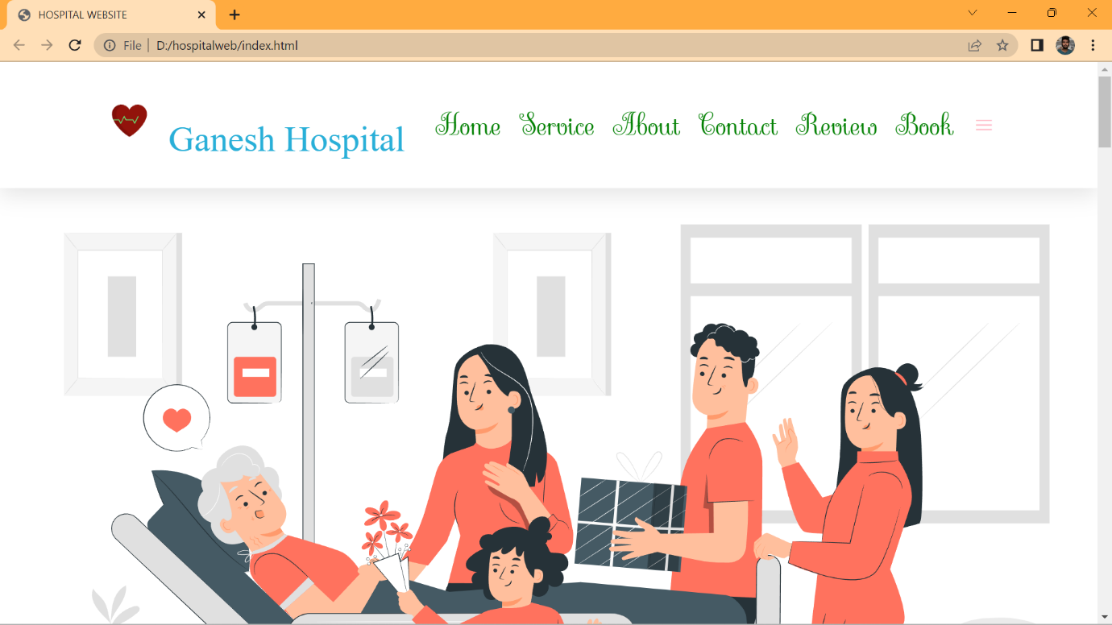

LOADING PAGE PHOTO

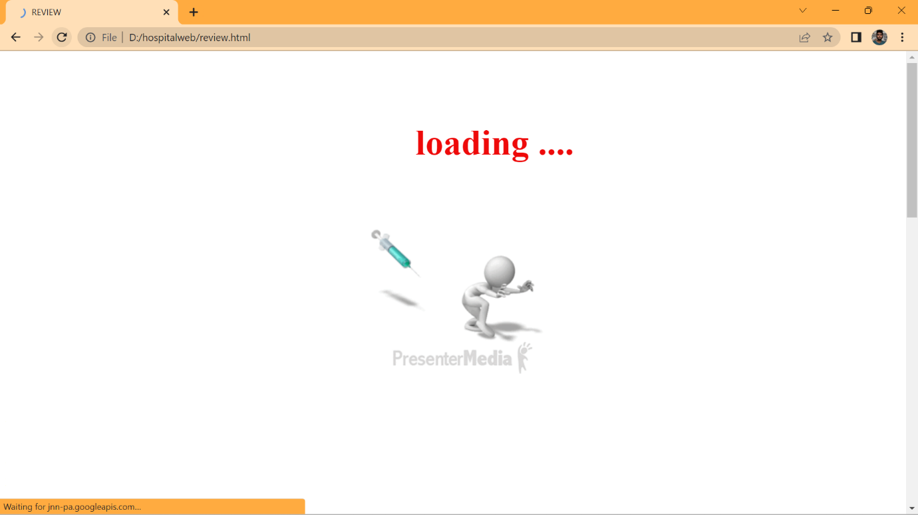

FACILITIES PAGE SCREENSHOT

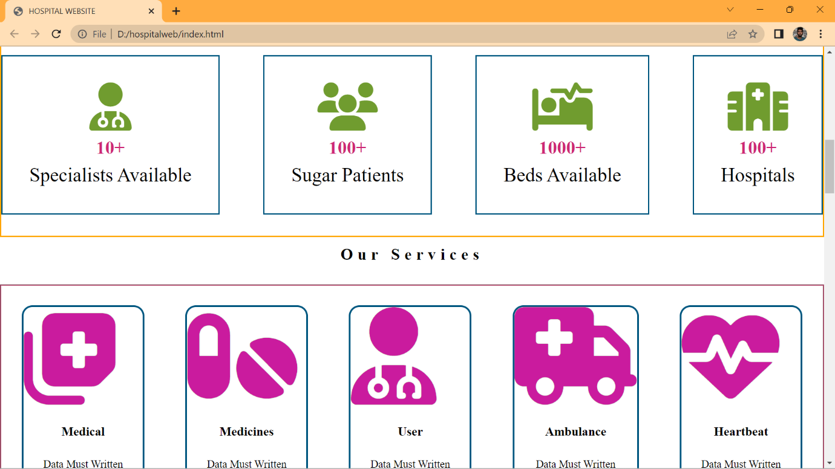

PROFESSIONAL DOCTORS PHOTO

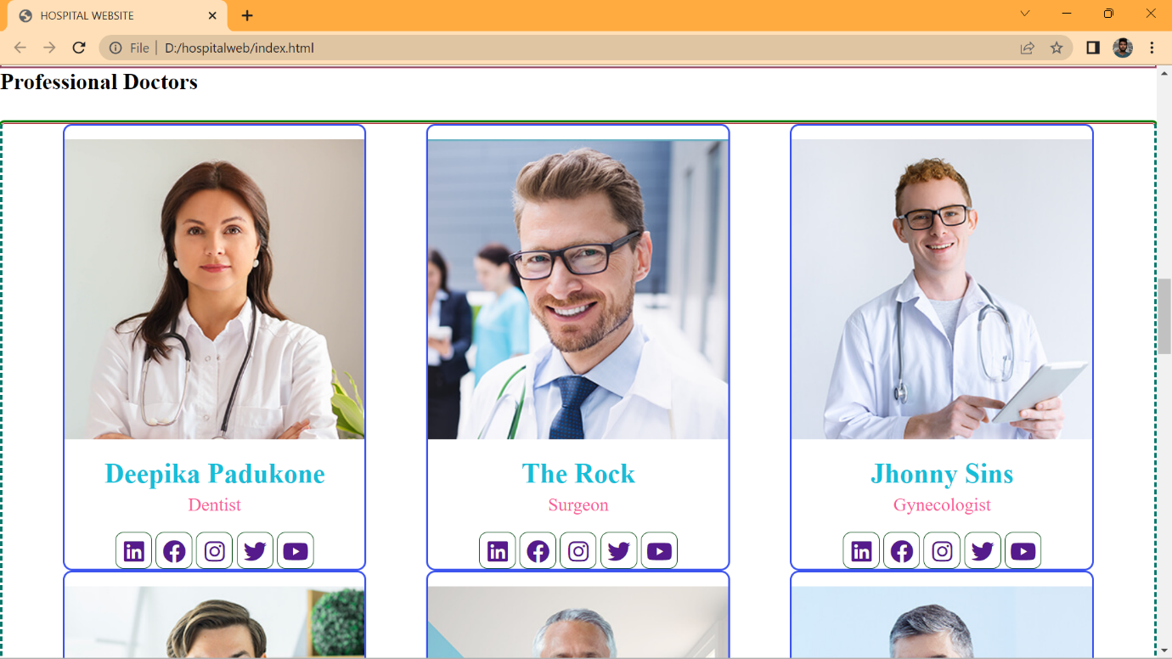

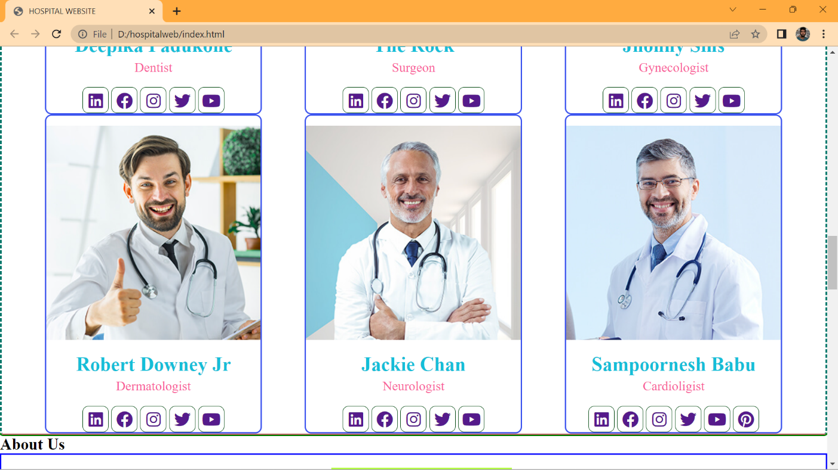

ABOUT US SCREEN SHOTS

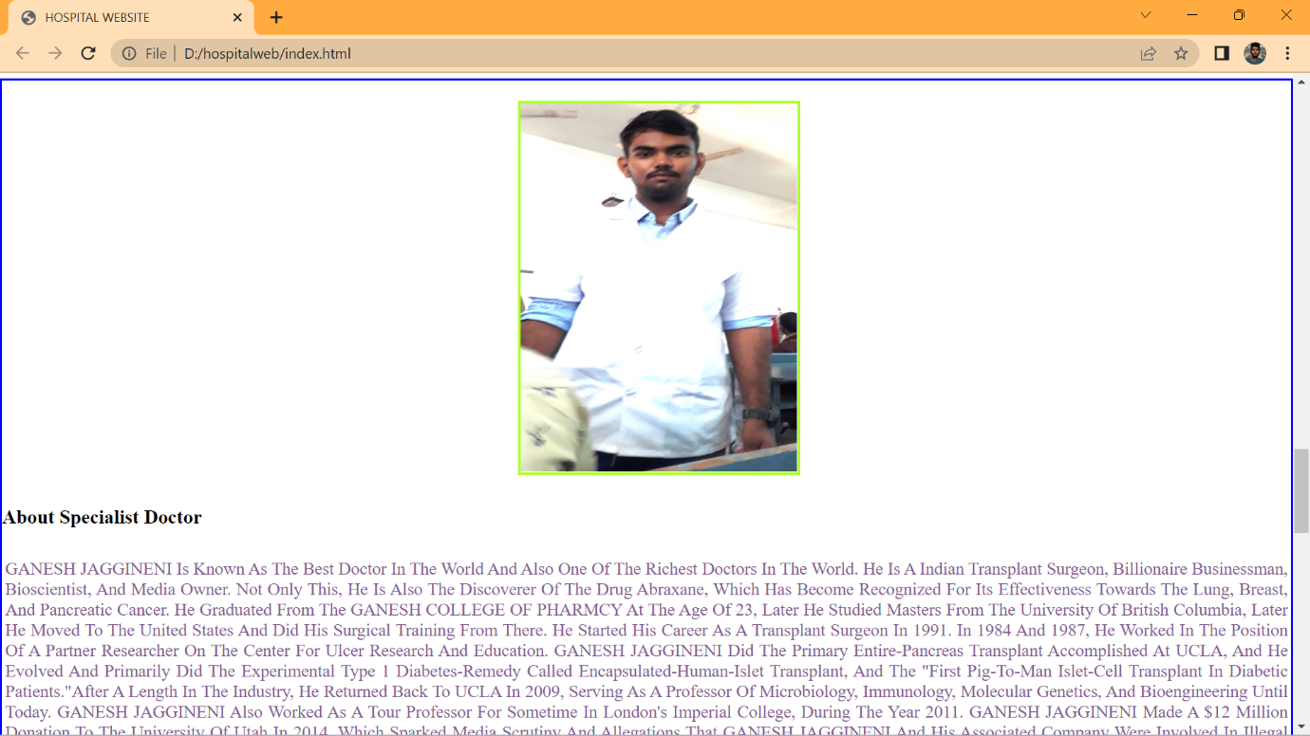

***NAVBAR TRANSFORMATION WEB SHOT***

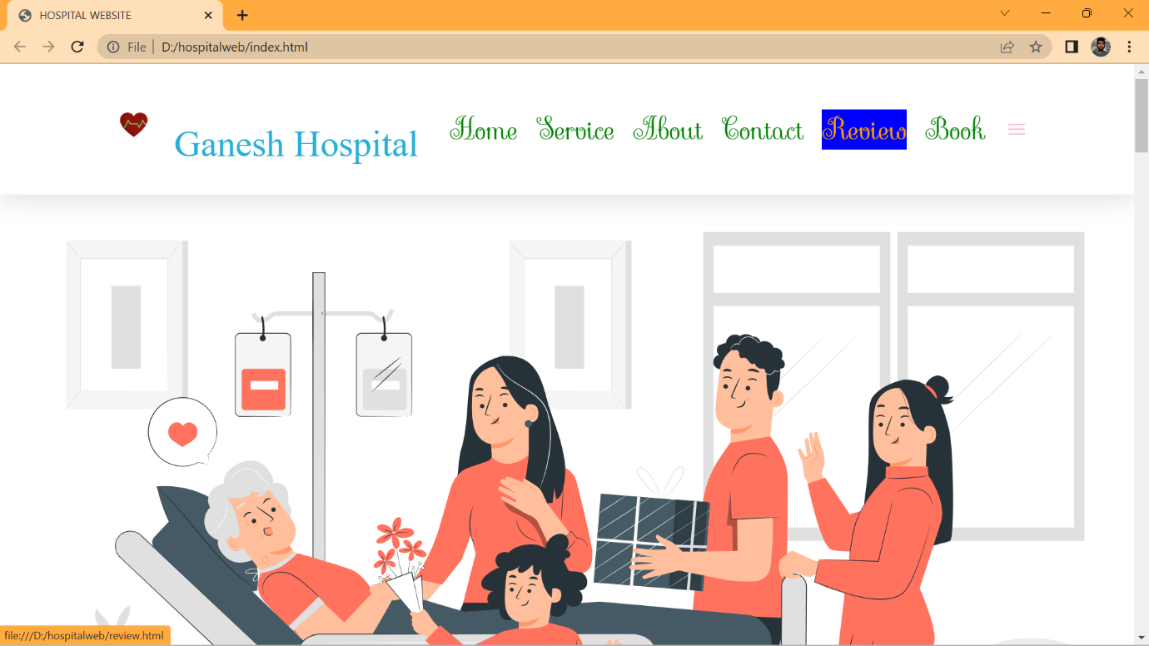

PATIENT REVIEW PAGE HTML

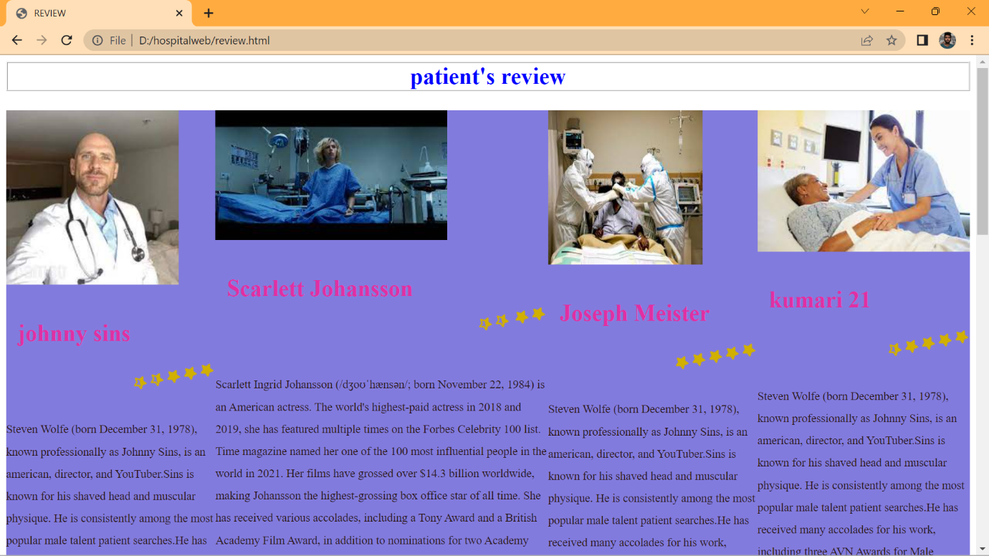

PATIENT REVIEW PAGE PHOTOS

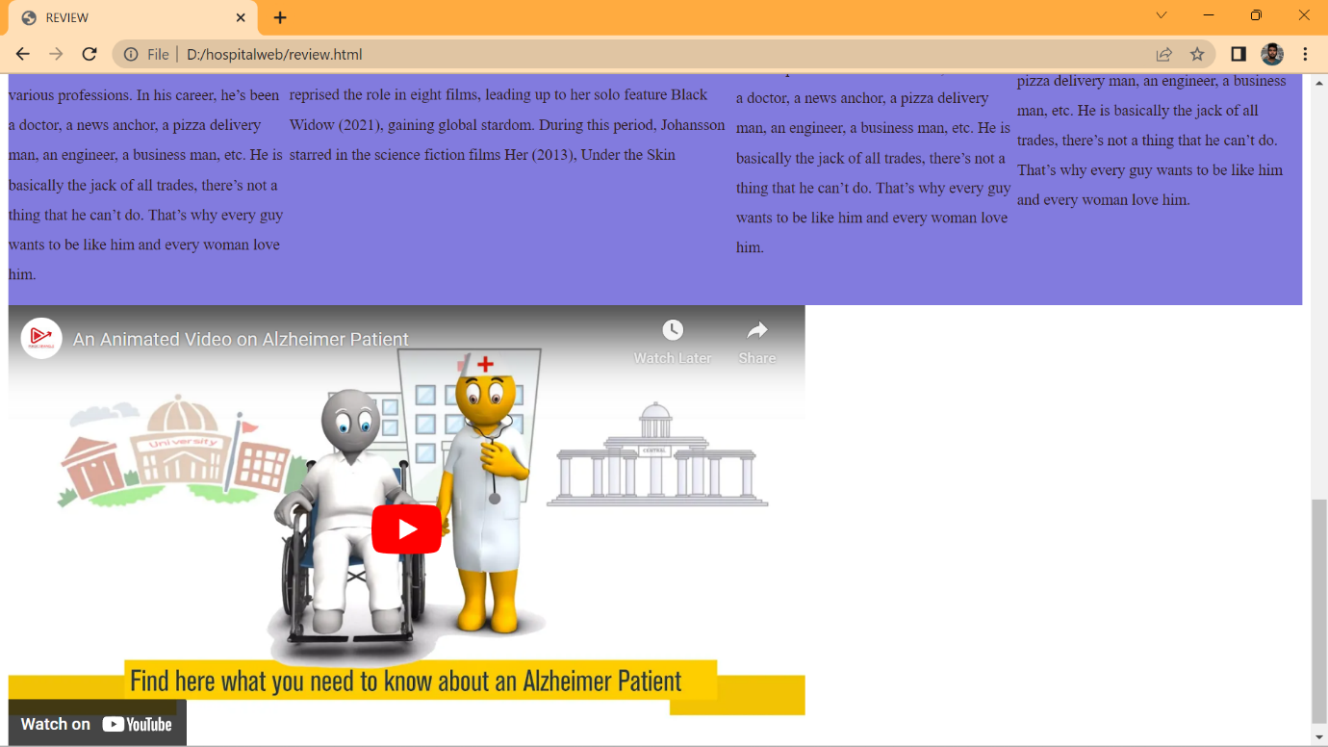

SEAT BOOKING PAGE PHOTO

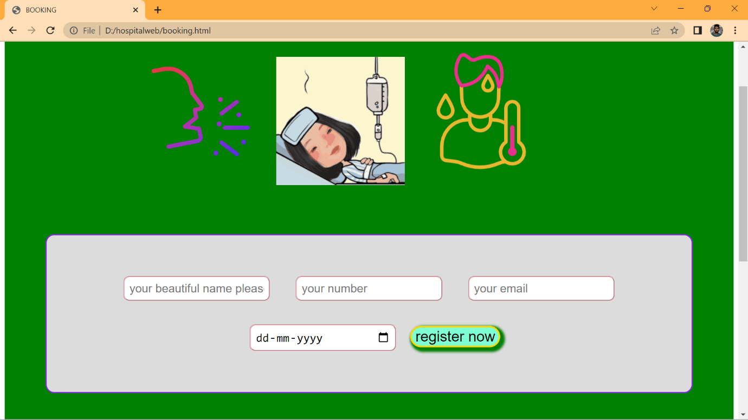

RESULTS

QUICK LINKS PAGE PHOTOS

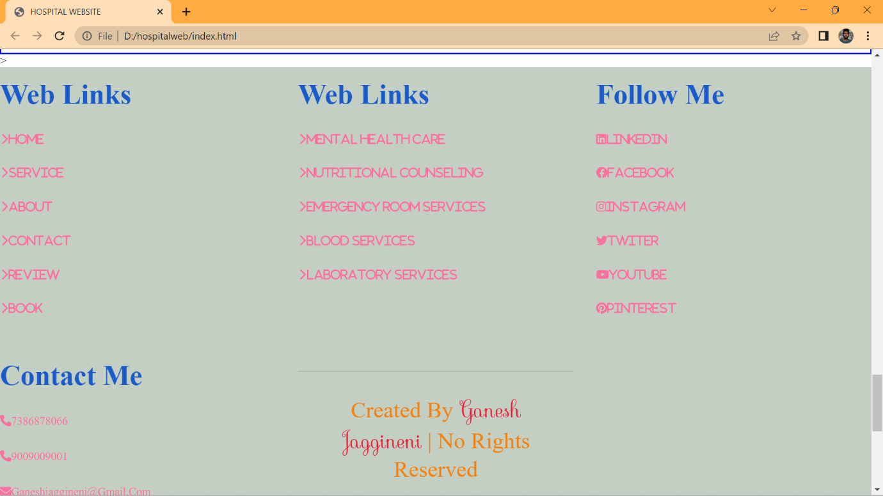

**MAPS IMAGE**

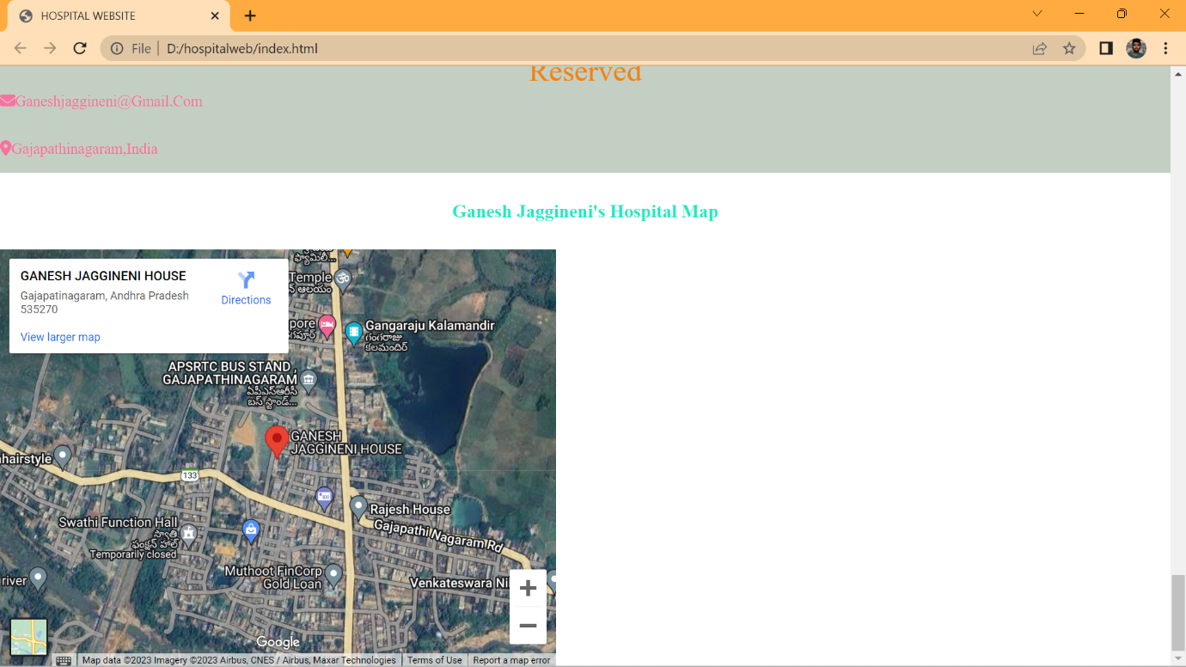

REFERENCES

W3SCHOOLS:

HTML-[HTML Tutorial (w3schools.com)](https://www.w3schools.com/html/default.asp)

CSS-[CSS Tutorial (w3schools.com)](https://www.w3schools.com/css/default.asp)

JAVASCRIPT-[JavaScript Tutorial (w3schools.com)](https://www.w3schools.com/js/default.asp)

YOUTUBE:

<https://www.youtube.com/watch?v=JESoRo3srzs>

<https://www.youtube.com/watch?v=GmEqwC1Azuc>

INFOSYS SPRINGBOARD

Html-[TOC - HTML5 - The Language | Infosys Springboard (onwingspan.com)](https://infyspringboard.onwingspan.com/web/en/app/toc/lex_17739732834840810000_shared/overview)

CSS - [TOC - CSS3 | Infosys Springboard (onwingspan.com)](https://infyspringboard.onwingspan.com/web/en/app/toc/lex_15281000932633230000_shared/overview)

JavaScript - [TOC - JavaScript | Infosys Springboard (onwingspan.com)](https://infyspringboard.onwingspan.com/web/en/app/toc/lex_18109698366332810000_shared/overview)